Class Activity 1 – MDP

NAME:N.AKSHAYA
REG.NO:192425129
COURSE CODE:MLA0305
COURSE NAME:REINFORCEMENT LEARNING

R-CODE:
# Markov Decision Process
grid_size <- 4
start <- c(1,1)
goal <- c(4,4)
state <- start
# Function to draw coloured grid
drawGrid <- function(state, step){
grid.newpage()
grid.text(
paste("Markov Decision Process - Step", step),
y=0.97,
gp=gpar(fontsize=18,fontface="bold")
)
for(i in 1:grid_size){
for(j in 1:grid_size){
fill <- "white"

if(i==start[1] && j==start[2])
fill <- "skyblue"
if(i==goal[1] && j==goal[2])
fill <- "lightgreen"
if(i==state[1] && j==state[2])
fill <- "red"
x <- (j-0.5)/grid_size
y <- 1-(i-0.5)/grid_size
grid.rect(
x=x,
y=y,
width=1/grid_size,
height=1/grid_size,
gp=gpar(fill=fill,col="black",lwd=2)
)
if(i==start[1] && j==start[2])
grid.text("S",x,y,gp=gpar(fontsize=18,fontface="bold"))
if(i==goal[1] && j==goal[2])
grid.text("G",x,y,gp=gpar(fontsize=18,fontface="bold"))
if(i==state[1] && j==state[2])
grid.text("A",x,y,
gp=gpar(col="white",
fontsize=18,
fontface="bold"))
}
}

# Legend
grid.text("Blue = Start Red = Agent Green = Goal",
y=0.03,
gp=gpar(fontsize=12,fontface="bold"))
}
# Simulation
step <- 0
total_reward <- 0
cat("=====================================\n")
cat(" MARKOV DECISION PROCESS SIMULATION\n")
cat("=====================================\n\n")
drawGrid(state, step)
cat("Step :", step,"\n")
cat("Current State :", state,"\n")
cat("Action : Start\n")
cat("Reward : 0\n\n")
Sys.sleep(1)
while(!all(state==goal)){
current <- state
if(state[1] < 4){
state <- c(state[1]+1,state[2])
action <- "Down"
}else{
state <- c(state[1],state[2]+1)
action <- "Right"
}
step <- step + 1
if(all(state==goal))
reward <- 100
else
reward <- -1
total_reward <- total_reward + reward
# Visual Output
drawGrid(state, step)
# Console Summary
cat("-------------------------------------\n")
cat("Step :", step,"\n")
cat("Current State :", current,"\n")
cat("Action :", action,"\n")
cat("Next State :", state,"\n")
cat("Reward :", reward,"\n\n")
Sys.sleep(1)
}
cat("=====================================\n")
cat(" FINAL SUMMARY\n")
cat("=====================================\n")
cat("Start State :", start,"\n")
cat("Goal State :", goal,"\n")
cat("Final State :", state,"\n")
cat("Total Steps :", step,"\n")
cat("Total Reward :", total_reward,"\n")
cat("Goal Reached : YES\n")

Full screenshot of Rstudio:
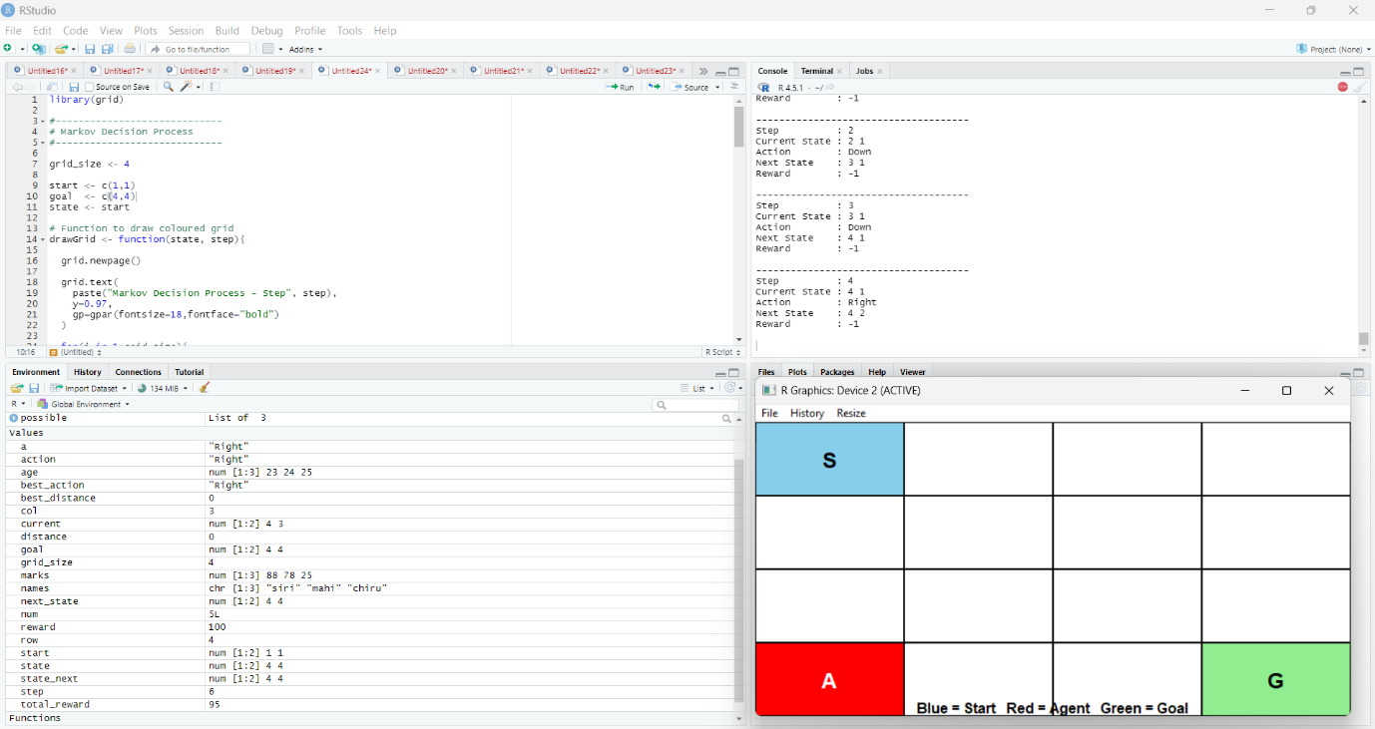
Visual result: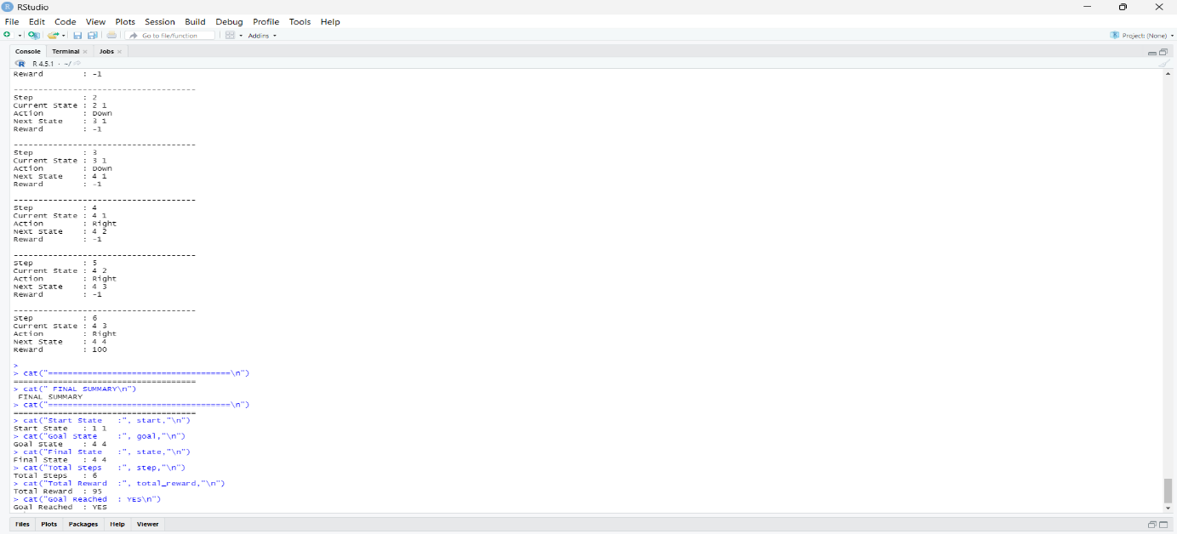

Summary result:
